Project 5-3: Configuring Microsoft Windows Security – Part 2
Estimated Time: 25 minutes
Objective: Use ConfigureDefender.
Description: As seen from the prior project, Windows security settings are found across several different screens. This can make it easy to overlook important settings and time-consuming to fine-tune the settings, especially when configuring the Microsoft Defender virus and threat protection product. A third-party tool called ConfigureDefender provides an easier interface. In this project, you download and use the ConfigureDefender product.

Note: ConfigureDefender is not installed on the computer but runs as a stand-alone application.

- Open your web browser and enter the URL github.com/AndyFul/ConfigureDefender. (If you are no longer able to access the program through the URL, use a search engine to search for “ConfigureDefender.”)
- Click ConfigureDefender.exe.
- Click Download.
- Open the file after the download has completed.
- Answer Yes if asked Do you want to allow this app to make changes to your device?
- The ConfigureDefender app now launches, as shown in Figure 5-15.

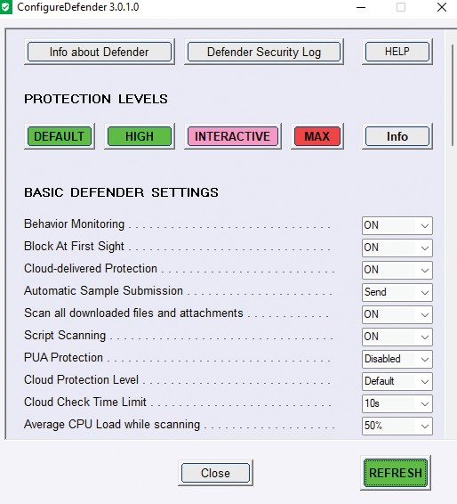
Figure 5-15 ConfigureDefender
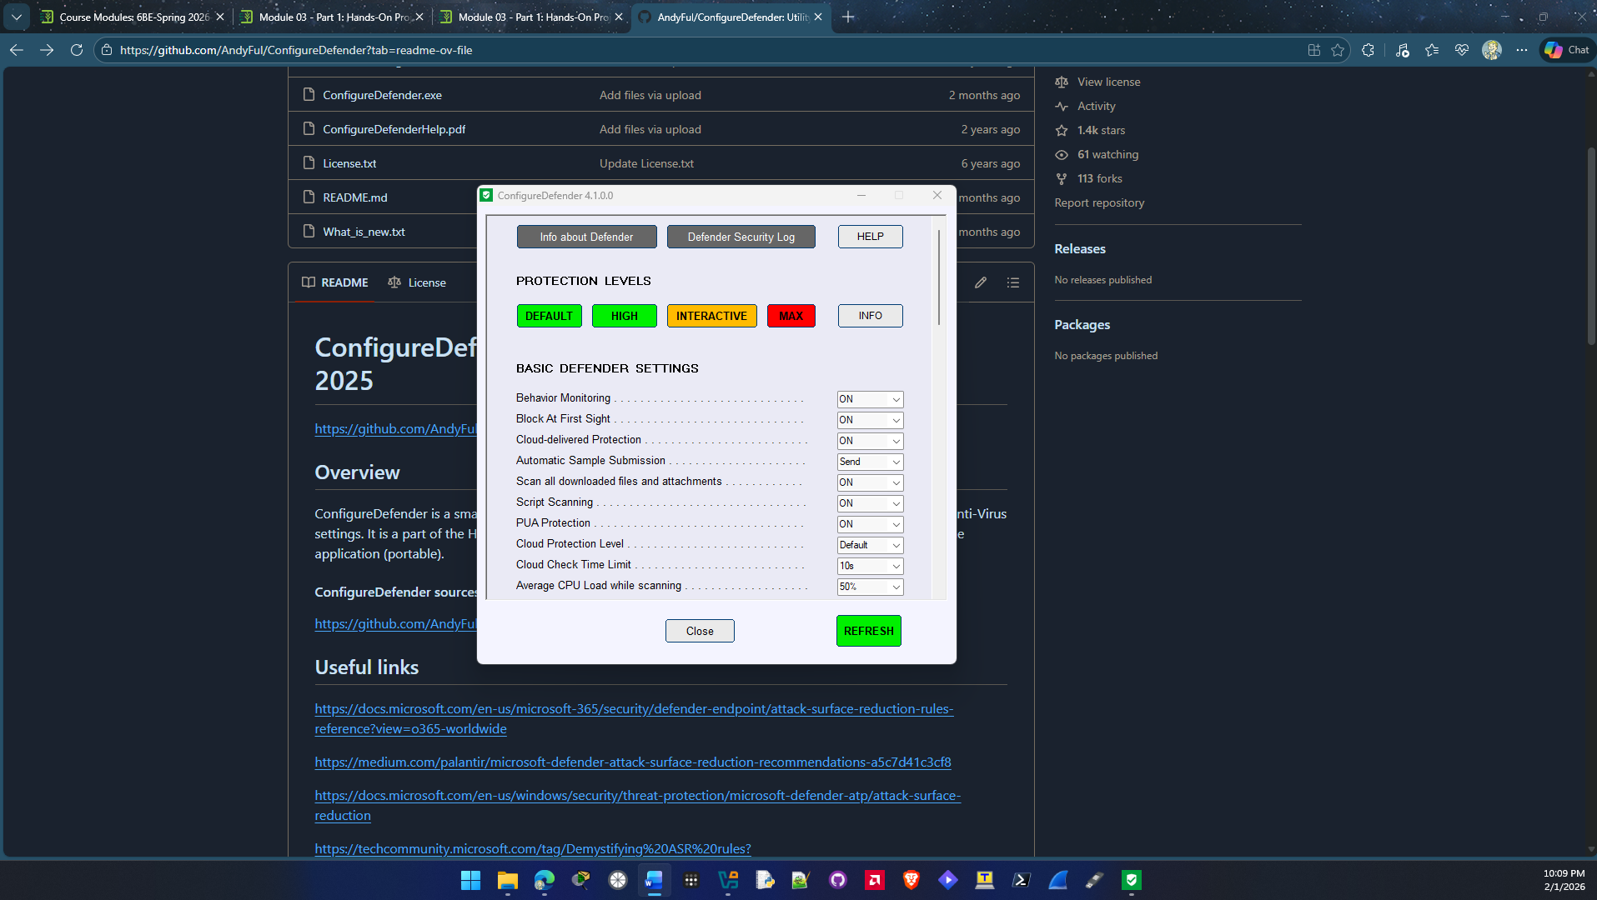

- Scroll down through the settings. Were you aware that there were so many different options for Windows Defender?
Yes I was aware of the amount of options I have been through windows defender settings before.

- Click the Info button to see the different protection levels. Close this window when finished reading.
- Click the HIGH button and then close the pop-up box.
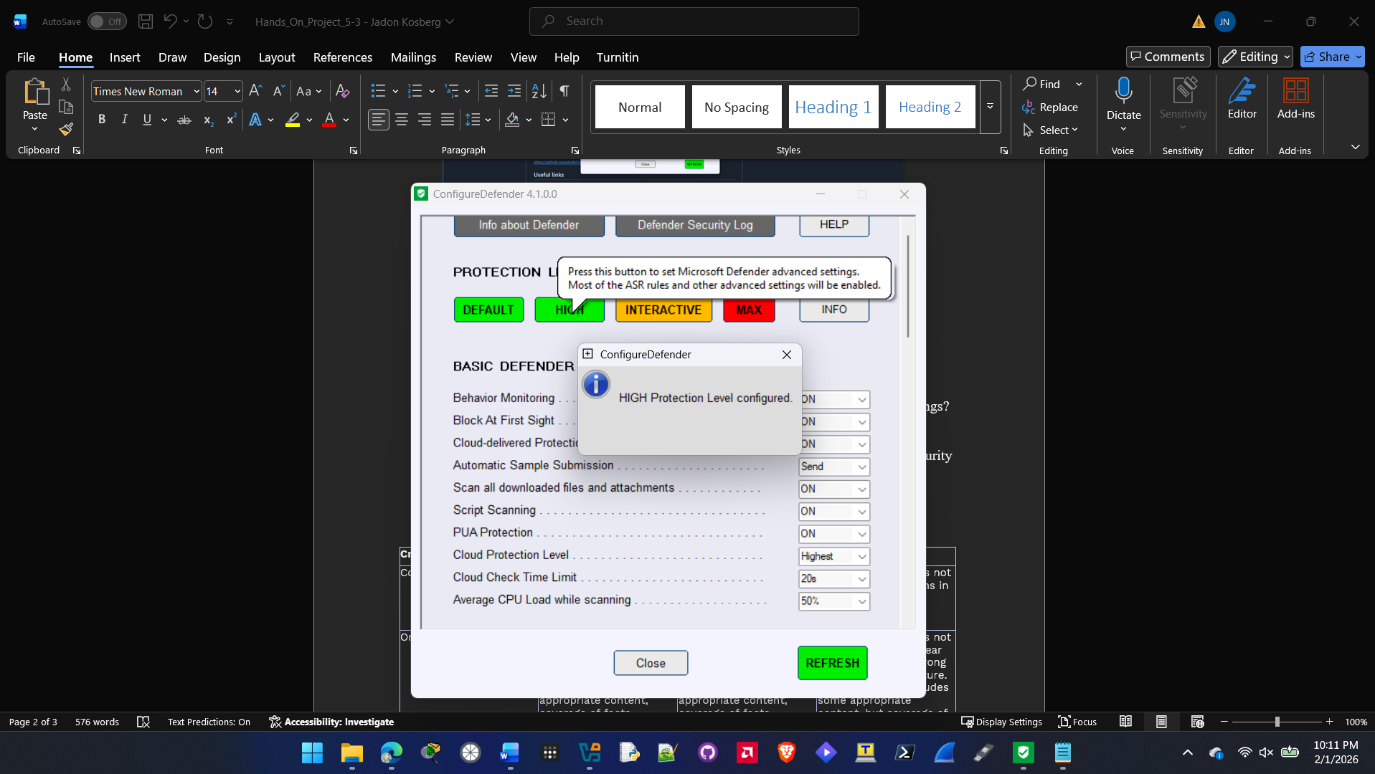
- Scroll down through the settings. How much stronger are they than the Default settings?
It seems to be much stronger than the default settings it turns on a lot of settings that were off.

- Click the MAX button and then close the pop-up box.
- Scroll down through the settings. How much stronger are they?
The settings are all turned on and maxed out this is the strongest and most secure windows defender can get.

- Finally, click either the DEFAULT or HIGH button to set your computer at the security level that you choose, or click DEFAULT to return to the basic security level.
- How easy is ConfigureDefender to use? Would you recommend it to others?
ConfigureDefender is very easy to use you can configure it with 4 preset buttons depending on your use case and needs. Yes I would recommend it to others looking to easily set up windows defender settings to make there computer more secure.

- Close all windows.

Criteria | Meets Requirements | Needs Improvement | Incomplete
Content | The assignment clearly and comprehensively addresses all questions in the assignment.  15 points | The assignment partially addresses some or all questions in the assignment.  8 points | The assignment does not address the questions in the assignment.  0 points
Organization and Clarity | The assignment presents ideas in a clear manner and with strong organizational structure. The assignment includes appropriate content, coverage of facts, arguments, and conclusions.  10 points | The assignment presents ideas in a mostly clear manner and with some organizational structure. The assignment includes appropriate content, coverage of facts, arguments, and conclusions.  7 points | The assignment does not present ideas in a clear manner or with a strong organizational structure. The assignment includes some appropriate content, but coverage of facts, arguments, and conclusions are not logically related and consistent.  0 points
Research | The assignment is based upon appropriate and adequate data collection and analysis of results from the activity or research from academically reliable sources.  5 points | The assignment is based upon adequate data collection and includes some analysis of results from the activity or research from academically reliable sources.  3 points | The assignment is not based upon appropriate data collection and includes no analysis of results from the activity or research from academically reliable sources.  0 points
Grammar and Spelling | The assignment has two or fewer grammatical and spelling errors.  5 points | The assignment has three to five grammatical and spelling errors.  3 points | The assignment has more than five grammatical and spelling errors, is incomplete, or is unintelligible.  0 points

